

Viernes, 31 de julio 2020

**Comprensión lectora**: Ordena las partes de una receta y escríbelas donde corresponda.

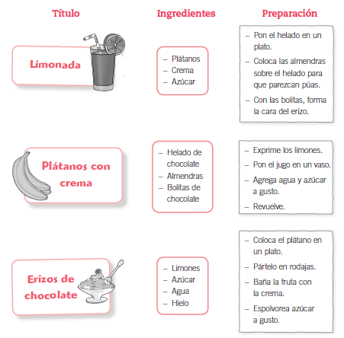

Viernes, 31 de julio 2020

Receta N1

Ingredientes:

Plátanos

Crema

Azúcar

Preparación:

____________________________________________

____________________________________________

____________________________________________

____________________________________________

____________________________________________

____________________________________________

____________________________________________

Viernes, 31 de julio 2020

Receta N2

Ingredientes:

Limones

Azúcar

Agua - hielo

Preparación:

____________________________________________

____________________________________________

____________________________________________

____________________________________________

____________________________________________

____________________________________________

____________________________________________

____________________________________________

Viernes, 31 de julio 2020

Receta N3

Ingredientes:

Helado de chocolate

Almendras

Bolitas de chocolate

Preparación:

____________________________________________

____________________________________________

____________________________________________

____________________________________________

____________________________________________

____________________________________________

____________________________________________

____________________________________________