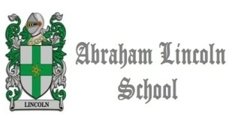
Past Simple 1 Worksheet 6º B

Miss Pìa Encina Carlesi

I. Write the correct form of the past simple verb you can use English Book or Dictionary remember “Irregular Verbs”

II. Tranlate the 20 past verbs into spanish

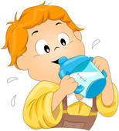 |  |  |  | 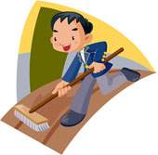
1. He__________  (drink) some milk. | 2. He ____________  (say) goodbye to his mother. | 3. They_________  (catch ) the bus to school. | 4. He___________  (have) a test. | 5. They___________  (draw) in the Art lesson.
 |  |  | 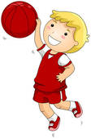 | 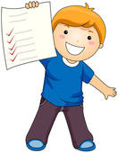
6. He__________  (meet) Daisy. | 7. She ___________  (answer) some emails. | 8.He __________  (make) some research. | 9. He ___________  (play) basketball. | 10. He _________  (get) an A in the English test.
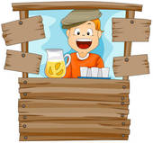  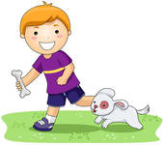 |  |  | 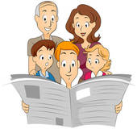
11. He __________  (take) his dog to the park. | 12. He_________  (sell) orange juice in the park . | 13. He_________  (write) a letter to his grandparents. | 14. They __________  (go) to the concert. | 15. They _________  (read) the newspaper.
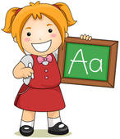 |  |  |  | 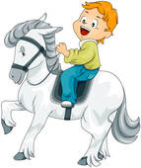
16. She__________  (do) her homework. | 17. They __________  (laugh) with a funny story. | 18. They ________  (leave) school at 4. | 19. They __________  (come) back home. | 20. He _________  (ride) his horse.

