Rewrite each sentence using passive voice for simple present tense.
2. The farmer grows carrots in his field.
..................................
..................................
6. Mr.Oven cleans our street every morning.
..................................
..................................

1. People produce cars in this factory.
..................................
..................................
5. The Hamiltons cook roast turkey on special days.
..................................
..................................

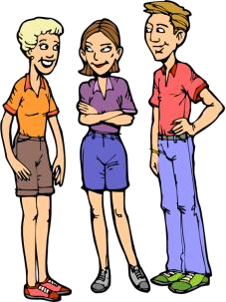
4. Everyone in this class loves and respects Diana.
..................................
..................................
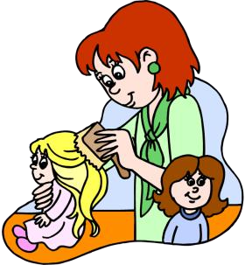
14. Eva's mother brushes her hair every morning.
..................................
..................................

3. Maisie takes a lot of nature photos at weekends.
..................................
..................................
7. Most women watch TV series at home.
..................................
..................................

PAssIve VoIce : sImple present tense worksheet

REMEMBER :

TENSE | ACTIVE VOICE | PASSIVE VOICE
PRESENT SIMPLE | The teacher punishes me.  The teacher punishes the boy.  The teacher punishes the boys. | I am punished by the teacher.  The boy is punished by the teacher.  The boys are punished by the teacher.
PRESENT CONTINUOUS | The teacher is punishing me.  The teacher is punishing the boy.  The teacher is punishing the boys. | I am being punished by the teacher.  The boy is being punished by the teacher.  The boys are being punished by the teacher.
PAST SIMPLE | The teacher punished me.  The teacher punished the boys. | I was punished by the teacher.  The boys were punished by the teacher.
PAST CONTINUOUS | The teacher was punishing me.  The teacher was punishing the boys. | I was being punished by the teacher.  The boys were being punished by the teacher.
PRESENT PERFECT | The teacher has punished me.  The teacher has punished the boy. | I have been punished by the teacher.  The boy has been punished by the teacher.
PAST PERFECT | The teacher had punished me.  The teacher had punished the boys. | I had been punished by the teacher.  The boys had been punished by the teacher.
FUTURE SIMPLE | The teacher will punish me.  The teacher will punish the boys. | I will be punished by the teacher.  The boys will be punished by the teacher.
GOING TO FUTURE | The teacher is going to punish me.  The teacher is going to punish the boys. | I am going to be punished by the teacher.  The boys are going to be punished by the teacher.
CONDITIONAL | The teacher would punish me.  The teacher would punish the boys. | I would be punished by the teacher.  The boys would be punished by the teacher,
MODALS | The teacher can punish me.  The teacher could punish me.  The teacher may punish me.  The teacher might punish me.  The teacher must punish me.  The teacher had to punish me.  The teacher shall punish me.  The teacher should punish me.  The teacher ought to punish me. | I can be punished by the teacher.  I could be punished by the teacher.  I may be punished by the teacher.  I might be punished by the teacher.  I must be punished by the teacher.  I had to be punished by the teacher.  I shall be punished by the teacher.  I should be punished by the teacher.  I ought to be punished by the teacher.

