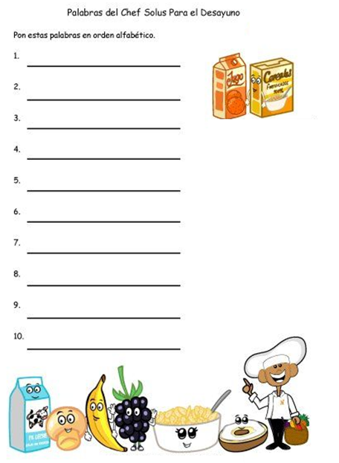

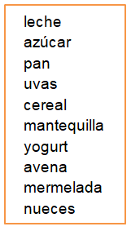

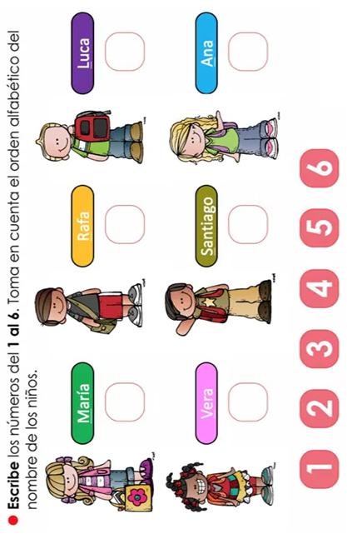



Ahora escribe oraciones usando los sustantivos propios que ordenaste. No olvides usar las mayúsculas y escribirlas con color rojo.

___________________________________________________________________________________________________________________________________________________________________________________________________________________________________________

___________________________________________________________________________________________________________________________________________________________________________________________________________________________________________

___________________________________________________________________________________________________________________________________________________________________________________________________________________________________________







Continúa…

¿Pusiste el punto final al terminar las oraciones?

___________________________________________________________________________________________________________________________________________________________________________________________________________________________________________

___________________________________________________________________________________________________________________________________________________________________________________________________________________________________________

___________________________________________________________________________________________________________________________________________________________________________________________________________________________________________





