Worksheet Nº2 : Past Simple 1º Medio

Fill in the blanks with the right forms of the verbs in brackets in past simple.
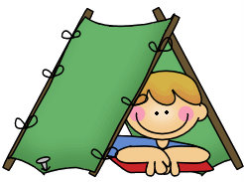
Last Easter holidays Jimmy and Paul ___________(go) camping in the mountain.
They _________________(spend) a wonderful time there. They ______________(wake up) early in the morning and then they ________________(go) for a walk. In the village they __________________(buy) everything they _______________(need).
In the afternoon they ___________________(play) football, ____________(watch)
the birds and ________________(swim) in the river.
They ________________(not have) a TV set, so after dinner they ______________
(talk) for a while and then they ________________(go) to sleep.
One night, Jimmy _______________(have) a very strange dream: they ______(be)
by the river watching the moon.
Suddenly they ______________(hear) someone calling “Hello! Hello!” They _____________(turn) around and they ______________(see) a strange creature.
It _____________(be) green and very small. He ________________( invite) them to go to his spaceship. There they ______________(meet) other strange creatures and a beautiful princess.
They ______________(sit) down round a table and they _____________(eat) some strange food. Jimmy _______________(drink) a glass of fruit juice. It ______________(taste) good so he ________________(ask) for another glass of it.
After a while he ______________(feel) a bit strange.
Oh, dear…he ________________(turn) green and small like the others. The princess _______________(not be) beautiful anymore and she ______________(look) horrible.
What was happening?
He ________________(open) his eyes and … what a relief! It ___________(be) only a dream!

